■ Special Edition on Car Purchase Trends
- Trends in New Car Purchasers by Age
- Purchased Car Type Trends
- Fuel Type Trends(Electronic cars, hybrids, etc)
- Car ownership trends (rent, sharing, subscription, etc)
Automotive Consumer Reports 19/20-3 ;
Soaring eco-friendly fuel cars, intensifying competition
- Eco-friendly fuel gains momentum after diesel blast
- A big turnaround opportunity for LGP that is pushed around by hybrid
- Hard to predict the market with the rapid increase of electronic cars

The eco-friendly fuel market is witnessing significant changes in its environments. Not only the market itself is growing rapidly but also competitions among the fuels are getting intensified. As the regulations on the purchase and modifications of LPG vehicles were lifted at the end of March this year, some chaotic fights are likely to unfold. It is worth noting whether or not LPG can outpace hybrids that have surpassed and have been running way ahead of LPG.

Out of the large-scale syndicated automobile studies carried out in July each year, we looked into the recent four year results to classify cars bought within a past one year into gasoline, diesel and eco-friendly cars by fuel type [Figure1], and then further segmented the eco-friendly cars into hybrids, LPG, electronic cars [Figure 2].
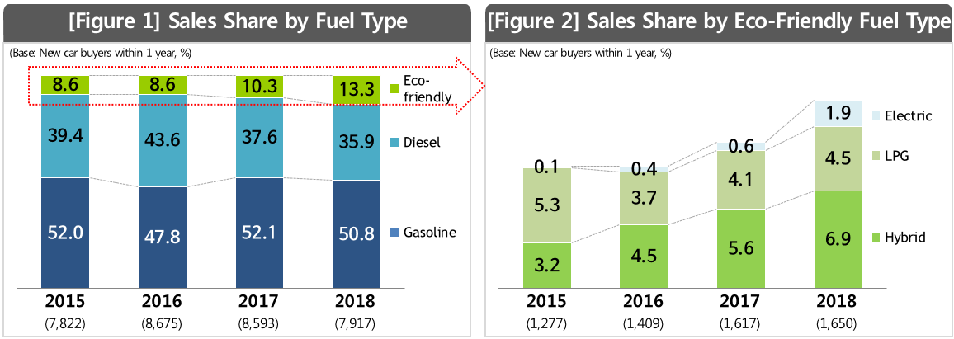

Looking at the fuel types of new cars sold for the four years from 2015 to 2018, gasoline with the largest sales share used to account for more than half of the market, but dropped to less than 50% for the first time in 2016 year next to diesel, to come back to its normal level in the following years, though. With the storm of imported diesel cars with high fuel efficiency, diesel grew rapidly to 43.6%, threatening gasoline (47.8%) in 2016, but later plunged to 35.9% in 2018 due to controversies over its fuel efficiency accuracy and fine dust generation. Environment regulations are likely to aggravate the sales share of diesel further. Eco-friendly fuels have been on a steep rise from 8.6% in 2016 to 10.3% in 2017 and to 13.3% in 2018. Overall, it is apparent that eco-friendly fuels are expanding while diesel is shrinking [Figure 1].
Among eco-friendly fuels, Hybrid's growth has been robust. The fuel increased by more than 1% points each year from 3.2% in 2015, tripling its share to 6.9% in three years. The growth of hybrids have been driven mostly by Japanese car makers, but recently, consumers’ evaluation of Korean hybrids has improved greatly. In particular, when it comes to fuel efficiency, Korean hybrids performed beyond consumers’ expectations. Not on a par with imported hybrids yet, Korean hybrids are known to have earned higher consumers’ satisfaction than diesel cars that brought about to the imported car frenzy. The emergence of Korean hybrids is a good news for a bigger hybrid market potential.

LPG occupied more than half of the eco-friendly fuel market at 5.3% in 2015, but dropped to 3.7% in 2016 due to regulations on consumer users. Although there has been a gradual recovery since then, the gap with hybrids is increasing and is still below its level in 2015. However, the government has taken steps to lift restrictions on the purchase and remodeling of LPG vehicles in March as part of its measures to reduce fine dusts. Also, the government announced that it will increase LPG car sales to 545,000 cars by 2022 through the introduction of a mandatory eco-friendly car sales system and an extension of the LPG car purchase subsidies¹⁾. Such environmental changes are likely to bring about a major change in the automobile fuel market competition structure.
The electric vehicle market share was only 0.1% in 2015, but it showed an explosive growth of 1.9% in 2018, more than three times of the previous year (0.6%). There is no doubt that electric cars will increase. However, it is difficult to predict how much it will grow further.

Nobody denies that the eco-friendly cars are the trend. However, it is hard to say which of the fuels and the combinations thereof is the most promising. In addition to existing hybrids, electric vehicles and LPG cars, hydrogen cars are also an alternative that the government and the domestic car industry support. It is really difficult to predict which fuel will dominate.

1) Source: 2019 Ministry of Environment Work Report
========================================================
◈ Reference: 「ConsumerInsight」 Annual Syndicated Automobile Study Outline.
ConsumerInsight has been conducting ‘Annual Syndicated Automobile Study’ in July, every year since 2001, on approx. 100,000 respondents per study. The following are the details of how the study is designed.
